Why diamonds are losing their allure

钻石为什么不香了

## As an investment category, at least

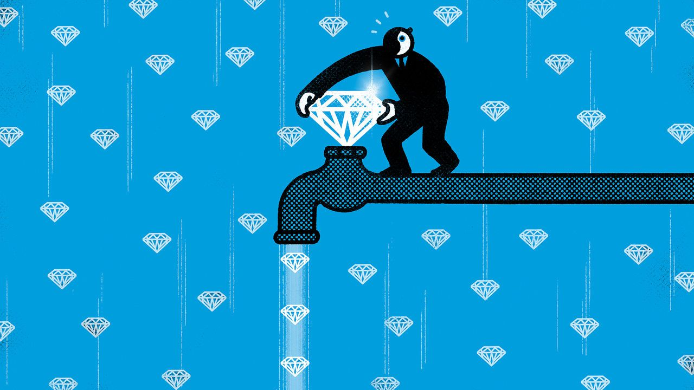

image: satoshi kambayashi

The appeal of a diamond, for a ring on a finger or to string on a necklace, rests on its sparkle. Its precise value is determined by how well the stone is cut, its colour, its size (also called its “carat”) and whether it contains flaws. The clearer, heavier, closer to colourless and more perfectly cut the rock, the better.

The appeal of a diamond for an investor is that, in addition to being nice to look at, it has historically offered a steady return on investment. Given the opacity of the market, and the broad variety of gems that are available, long-run price data are scarce. But a paper by Luc Renneboog of Tilburg University, which was published in 2015, analysed thousands of auctions each year, finding that the average return between 1999 and 2012 rivalled those of stocks and property. Holders of diamonds would have earned a handsome 8% or so a year.

钻石的吸引力在于它的闪耀，不论是作为戒指上的饰品还是项链上的串联。钻石的确切价值取决于切割的精度、颜色、大小（也称为“克拉”）以及是否带有瑕疵。石头越清晰、重量越高、接近无色并且切割得越完美，其价值就越高。

对于投资者而言，钻石的吸引力在于除了观赏价值外，它历史上一直提供稳定的投资回报。由于市场的不透明性和可用的宝石种类繁多，长期价格数据很少。然而，蒂尔堡大学的卢克·伦内布格（Luc Renneboog）在2015年发表的一篇论文分析了每年数千次拍卖数据，发现1999年至2012年期间的平均回报率与股票和房地产相媲美。持有钻石的人每年可获得可观的约8%回报。

Recently, though, these steady returns have given way to enormous volatility. De Beers, a consortium that has long monopolised the supply of diamonds, has reduced the price of two-to-four carat uncut stones—a popular category because they can be made into one-to-two carat engagement rings—by 40%, according to Bloomberg, a news service. On September 13th the company announced that it would re-run its iconic “a diamond is forever” advertising campaign in an attempt to boost demand.

Stable returns in the past were partly brought about by steady demand. Just as with the investment case for gold, another rare and precious commodity, the logic for holding diamonds tends to be strongest during periods of economic uncertainty. At the same time, the main use of diamonds is in jewellery, which means that prices have tended to do well during periods of prosperity, too.

然而，最近这些稳定回报已经转变为巨大的波动。据彭博社报道，长期垄断钻石供应的德比尔斯（De Beers）财团将2至4克拉未切割钻石的价格下调了40%。这个类别的钻石非常受欢迎，因为它们可以制成1至2克拉的订婚戒指。9月13日，该公司宣布将重新推出标志性的“一颗钻石永恒”的广告活动，以提振需求。

过去的稳定回报部分是由于稳定的需求。和黄金等其他稀缺宝贵商品的投资情况一样，持有钻石的理由在经济不确定时期最为强烈。同时，钻石的主要用途是用于珠宝，这意味着在繁荣时期价格往往表现良好。

But the most important factor was monopolistic supply. For more than a century De Beers managed to dominate the production of gems. This market structure facilitated steady price increases in two ways, as Mr Renneboog has noted. First, by stockpiling supplies De Beers created scarcity. Second, the firm curbed speculation, and the volatility it brings. Although De Beers controlled some 80% of the global supply of diamonds in the 1980s, since then its share has been eaten into by competitors, which include Alrosa, a Russian rival. The company now produces just a third of supply.

Another problem is emerging from laboratories. They are producing artificial gems, which are made by applying pressure to carbon, rather than digging stones from the ground, and are identical to the naked eye. Such stones have been available since the 1980s, but even as recently as 2018 made up a tiny fraction of the market, at just a few percentage points. In the years since, more lab-grown jewels have entered the market—and their market share has risen to around a tenth.

最重要的因素是垄断供应。德比尔斯（De Beers）在一个多世纪以来一直成功地主导着钻石的生产。正如伦内布格先生所指出的，这种市场结构以两种方式促进了价格的稳定增长。首先，通过库存储备，德比尔斯创造了供应的稀缺性。其次，该公司抑制了投机行为和带来的波动性。尽管在上世纪80年代，德比尔斯控制了全球约80%的钻石供应，但自那时以来，竞争对手（包括俄罗斯的竞争对手阿尔罗萨）逐渐侵蚀了其市场份额。如今，该公司只生产全球供应的三分之一。

另一个问题是实验室合成钻石的出现。它们是通过对碳施加压力而不是从地下开采钻石来制造的，并且在肉眼下与天然钻石完全相同。这样的人造钻石自上世纪80年代就已经问世，但即使在2018年，它们在市场上仅占极小比例，只有几个百分点。然而，最近几年，越来越多的实验室合成钻石进入市场，它们的市场份额已经上升至约十分之一。

De Beers may have inadvertently hastened this transition. The company began to sell lab-grown diamonds at rock-bottom prices in 2018, when such stones fetched about 80% of the price of mined ones. The goal was to differentiate between the two types of gems, in order to diminish the appeal of lab-grown stones. The Clear Cut, a New York-based purveyor of engagement rings, has adopted guerrilla marketing tactics to make the same point. It offers customers who buy a ring worth $10,000 or more a free lab-grown alternative, which can be used as a “travel ring” when visiting dubious places. Many lab-grown stones now fetch just 20-30% of the price of similar mined stones.

De Beers argues that, as the supply of lab-grown gems accelerates, the price gap between the two types of stone will continue to widen, making the newcomers unappealing for engagements. If recent price movements are anything to go by, though, the tactic appears likely to backfire—after all, mined prices are plunging in the wake of lab-grown ones.

戴比尔斯可能无意中加快了这一转变。该公司在2018年开始以极低价格销售人造钻石，当时这种石头的价格只相当于开采钻石的80%。公司的目标是区分这两种宝石，以减少人造钻石的吸引力。纽约珠宝商The Clear Cut采用游击营销策略来传达同样的观点。他们向购买价值10,000美元或更高的戒指的顾客提供免费的人造钻石替代品，这些人造钻石可以用作“旅行戒指”，在访问可疑地点时使用。目前，许多人造钻石的价格仅相当于类似开采钻石的20-30%。 戴比尔斯认为，随着人造宝石供应的加速，两种宝石之间的价格差距将继续扩大，使得新进入市场的钻石对于订婚市场不再具有吸引力。然而，如果近期价格变动是一个参考，这种策略似乎可能会适得其反——毕竟，在人造钻石的影响下，开采钻石的价格正在急剧下降。

Admittedly, this may not be entirely the result of a structural shift in the market. American couples date for about three years before getting engaged, and thanks to covid-19 very few people were out and about meeting potential husbands or wives in 2020. An unusually small number of people are probably getting engaged this year.

But this is the sort of fluctuation an all-powerful diamond cartel would have been able to smooth out by reducing supply. Slashing prices instead is a clear indication of diminished market power. That is good news for those looking to pop the question or acquire a new trinket. It is rather less appealing for those considering investing in the gems.

诚然，这可能并非完全是市场结构性转变的结果。在美国，夫妇在订婚前通常会约会大约三年，而且由于COVID-19疫情，2020年几乎没有人外出与潜在的丈夫或妻子见面。今年可能只有异常少数的人会订婚。 然而，对于一个拥有无比权势的钻石垄断集团来说，这种波动本应通过减少供应来平缓。而削价则明确显示市场力量的减弱。对于那些准备求婚或购买新饰品的人来说，这是个好消息。但对于考虑投资这些宝石的人来说，吸引力就稍微减弱了一些。